

**Roulette Game**

This Roulette game was created by Alex Villaseñor from Playmex, game designer and professional gambler, with the collaboration of Matthew Shaile, game developer.

**Introduction**

This game was created in full in Unity3D version 2018.3.3f1

Just press PLAY to start the game.

**Rules:**

This Roulette have the European and American versions

**The Game contains:**

⦁ Roulette Table 3D model

⦁ American and European version

⦁ Random ball launch

⦁ Six types of Chips

⦁ Complete UI Assets

⦁ History panel display

⦁ Chip value display

⦁ Winner number display

⦁ Six types of chip piles

⦁ Full game code

⦁ PSD chip file (for custom colors)

**Basic Instructions**

**Customize the layout**

Feel free to move the buttons around, make the chips bigger or change the UI position.

Don't worry if you don't see the UI canvas at first. The UI is quite big so you will have to zoom out to see it (see image below)

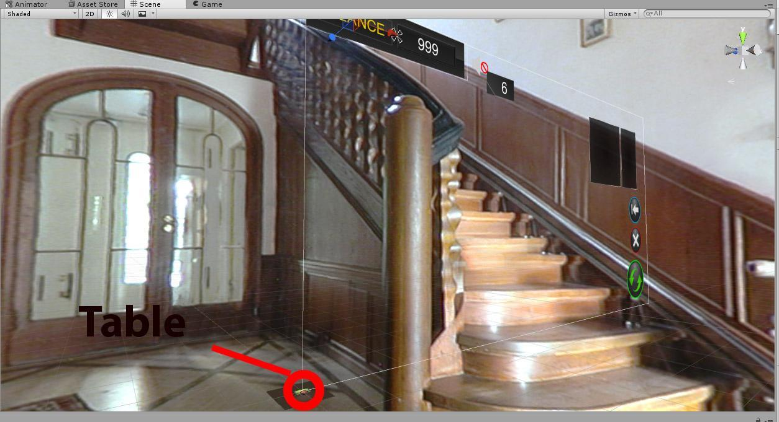

(The wheel can be edited if you know how physics simulations work. We are not to blame if the physics patterns are broken)

**How do I change the language?**

Easy! Just write into the editable text you see. Take into account you might have to make the text from “Wrap” into “Overflow”.

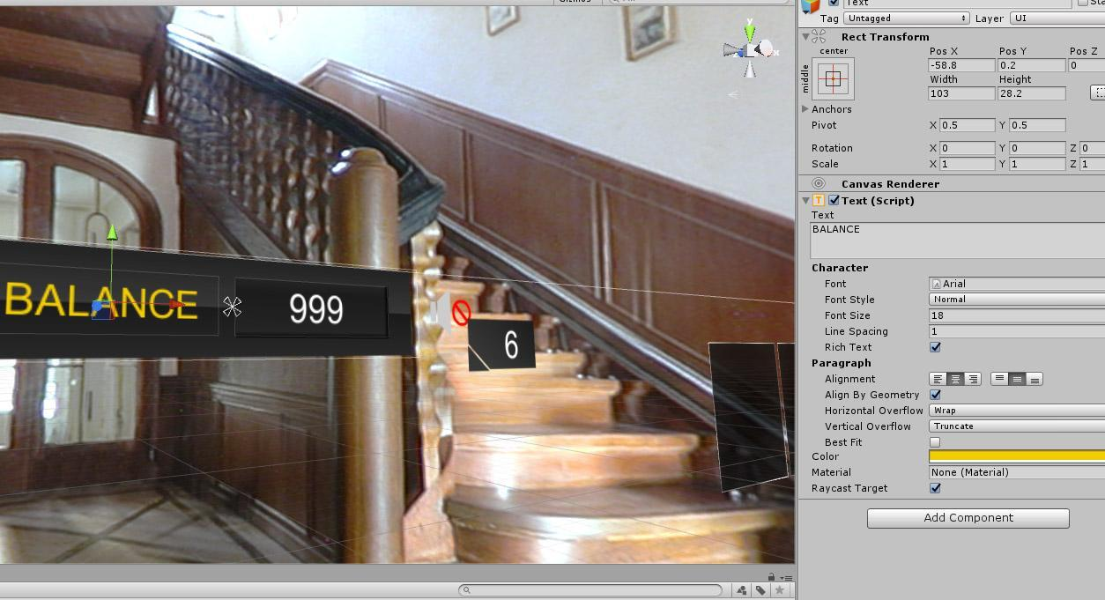

**How do I change to the Mobile version?**

Our developer made a Debug to be able to see the Mobile version once the play button is press.

Go to the “DebugManagerMobile” in the right then click the box “Force Mobile” press play and you will see the Mobile version. (see image below)

You might have to change quality and move lights for the mobile version. Remember that some old phones won't pick up the highest quality or it will look different to newest and more powerful phones.

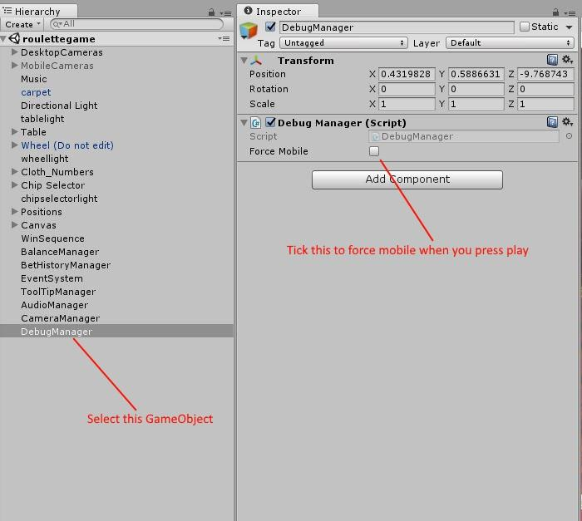

**I don't like the color of the Chips**

Luckily, we have added a PSD file (“chips fbx” folder) to the package containing the colors for the chips.

Just open the file "ChipEditor.psd" in Photoshop and change the hue. Easy!

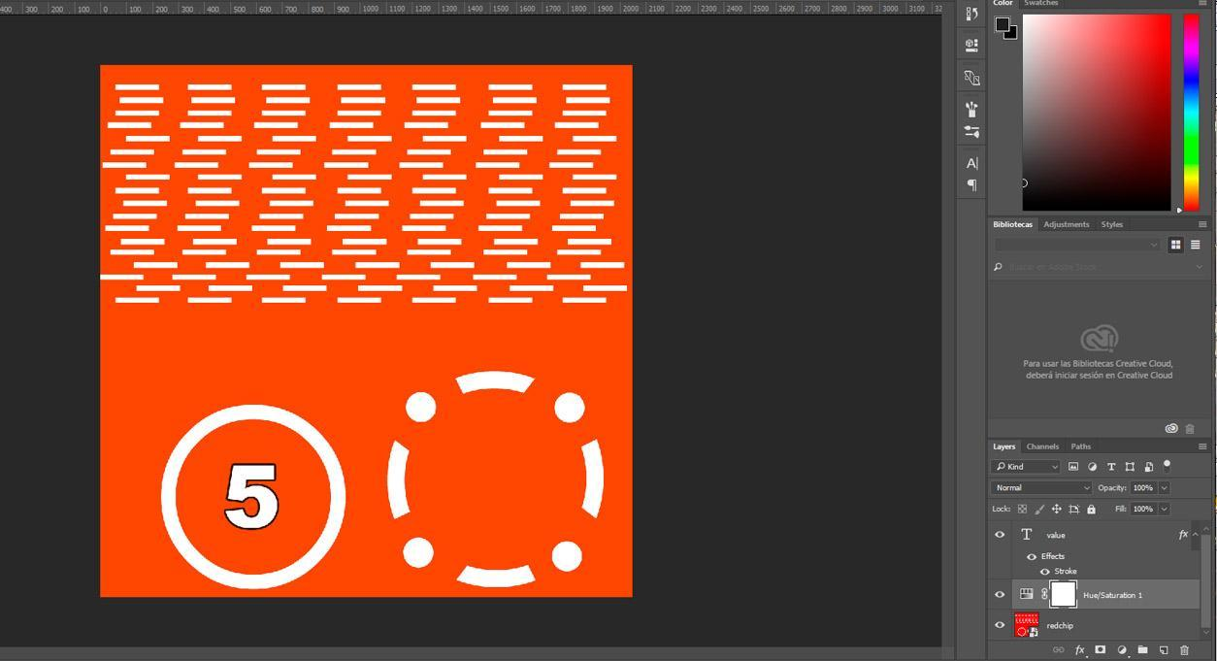

**YOU ARE READY TO GO!**

If you have any problems, questions or would like a quote for a custom game, please contact us via email:

alex@playmex.com.mx

We are available 24 hours to help you with anything you need.

THANK YOU

Playmex Team.